Software Engineering Lab Experiments
Laboratory Manual

Name : Pramith Maredukonda
Register Number: 192372174
Department : CSE AI
Course : CSA1011
Faculty : Dr. Rami Reddy

SAVEETHA SCHOOL OF ENGINEERING

Experiment No. 1
Create a Kanban Board to Visualize the Tasks using Jira Software

Aim
The objective of this experiment is to create a Kanban Board using Jira Software, add sample tasks, and simulate a software development workflow by moving tasks through different stages such as To Do, In Progress, and Done.

Software Requirements
Software | Version
Jira Cloud | Web Application
Web Browser | Google Chrome / Microsoft Edge
Internet Connection | Required

Theory
Jira is a popular project management and issue tracking tool used by software development teams to plan, monitor, and manage projects.
A Kanban Board is a visual workflow board that organizes work into columns representing different stages of development. Team members move tasks from one column to another as work progresses. Kanban improves visibility, reduces bottlenecks, and helps teams focus on ongoing work.
In software engineering, Kanban is widely used because it supports continuous delivery, improves collaboration, simplifies task tracking, and enables project managers to monitor progress in real time. It is easy to understand and suitable for agile development practices.

Procedure
Step 1
Open a web browser on your system.
Navigate to the Jira Cloud website by entering its URL in the address bar.
Sign in using your registered Jira account credentials.
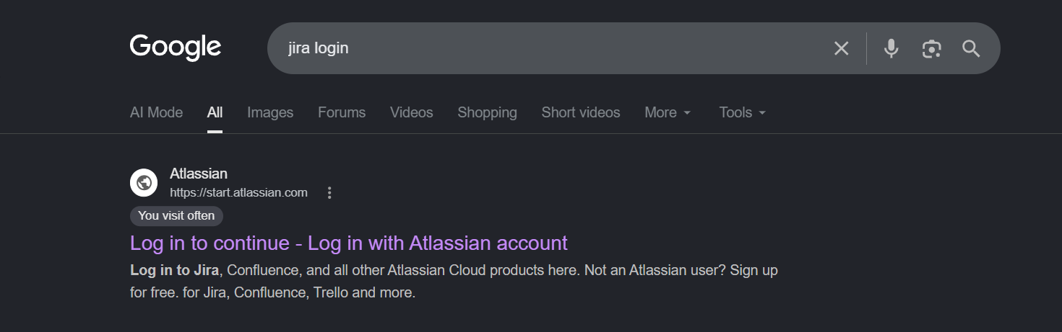
Figure 1. Opening Jira Cloud.
Step 2
After logging in successfully, click the "Jira" option available in the left navigation panel.
This action opens the main Jira workspace where projects and boards can be managed.
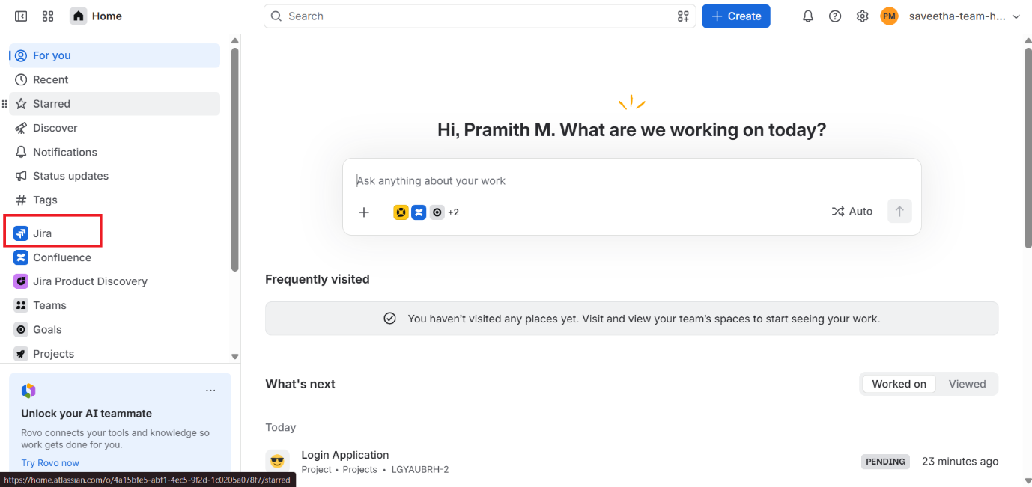
Figure 2. Opening Jira Workspace.
Step 3
Click the "Create Space" button located within the Jira workspace to begin creating a new project space.
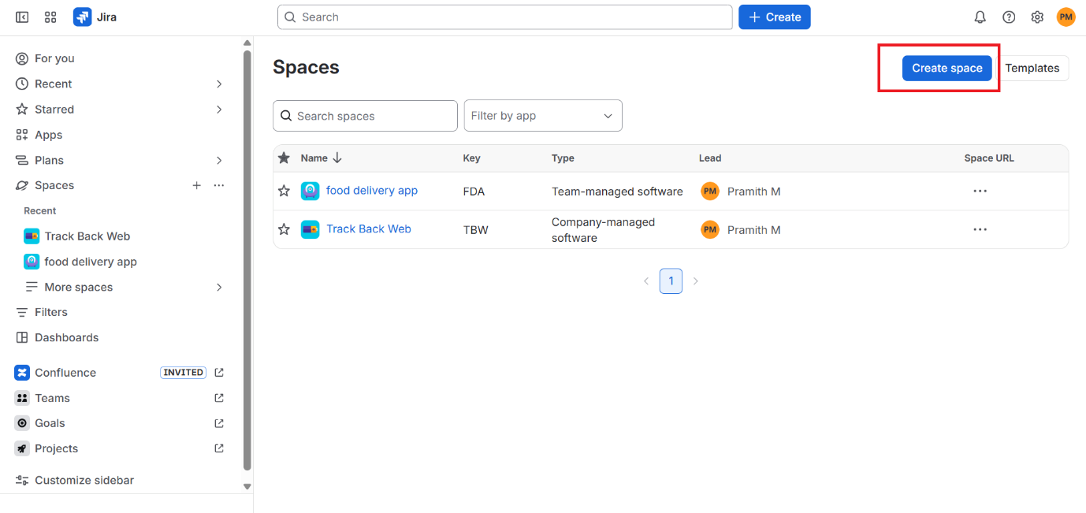
Figure 3. Creating a New Space.
Step 4
Under the Category option, select Software Development.
Select the Kanban Template from the list of available templates.
Click the Next button to proceed.
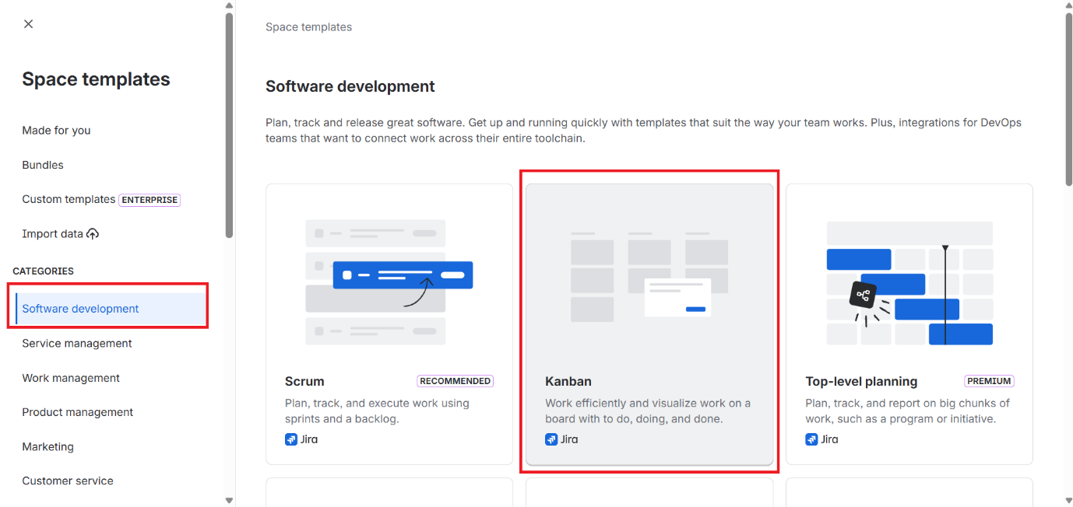
Figure 4. Selecting the Kanban Template.
Step 5
Enter the project Name as "Student Task Management System".
Choose the Management Type as Company-managed.
Enter the project Key as "STMS".
Click the Next button to complete the space setup.
Screenshot Placeholder
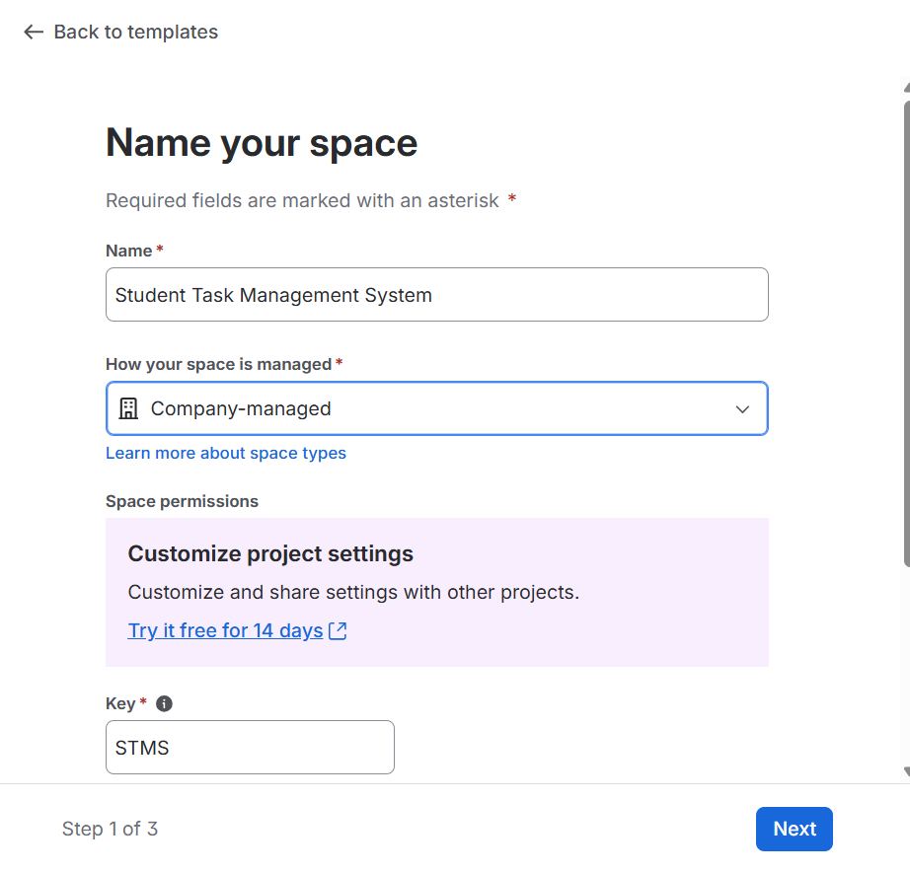
Figure 5. Entering Space Details.
Step 6
The Kanban Board is created successfully and displayed on the screen.
The board contains the following workflow columns:
- Backlog
- Selected for Development
- In Progress
- Done
The Backlog column holds tasks that are yet to be started. Selected for Development contains tasks chosen for the current cycle. In Progress represents tasks currently being worked on, and Done contains completed tasks.
Screenshot Placeholder
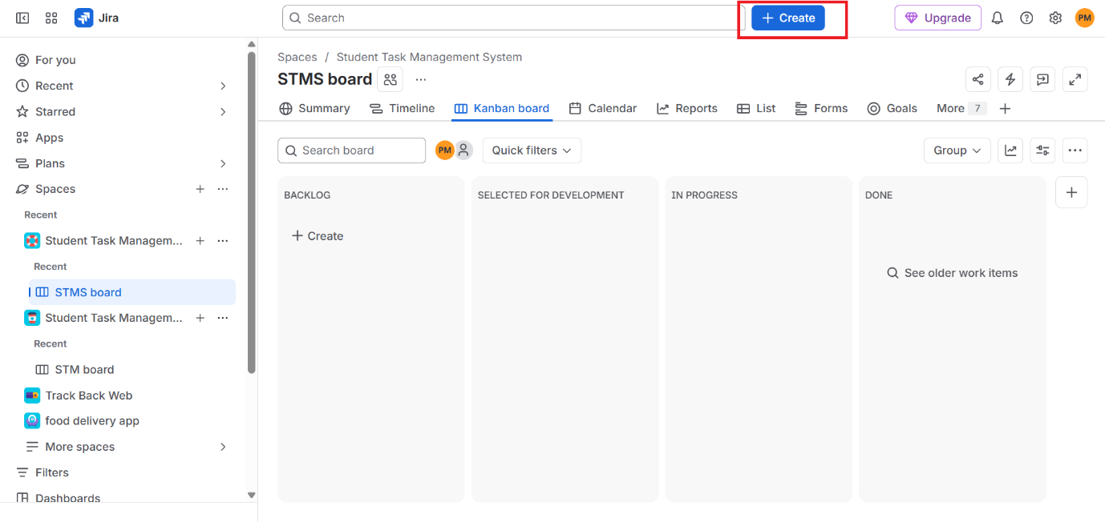
Figure 6. Newly Created Kanban Board.
Step 7
Click the Create button to add new tasks to the board.
Add the following five sample tasks as listed in the table below.
Task ID | Task Name | Description
STM-1 | Gather Project Requirements | Collect functional and non-functional requirements.
STM-2 | Design Login Page | Design the login user interface.
STM-3 | Develop Database | Create database tables and relationships.
STM-4 | Implement User Authentication | Develop login and registration functionality.
STM-5 | Testing and Bug Fixing | Test the application and fix defects.

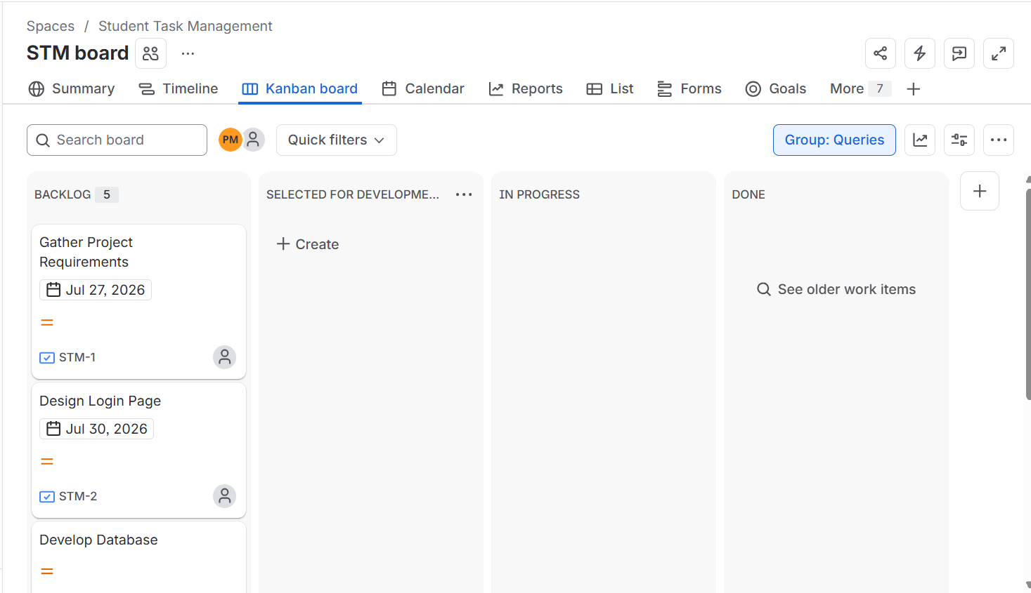
Figure 7. Creating Sample Tasks.
Step 8
Move the tasks across the different workflow stages by dragging and dropping them between columns, as shown below:
Gather Project Requirements: Backlog → Selected for Development → In Progress → Done
Design Login Page: Backlog → In Progress → Done
Develop Database: Backlog → In Progress
Testing and Bug Fixing: Selected for Development

Moving issues across the board represents the actual progress of tasks during the software development process, allowing the entire team to visually track project status at any point in time.
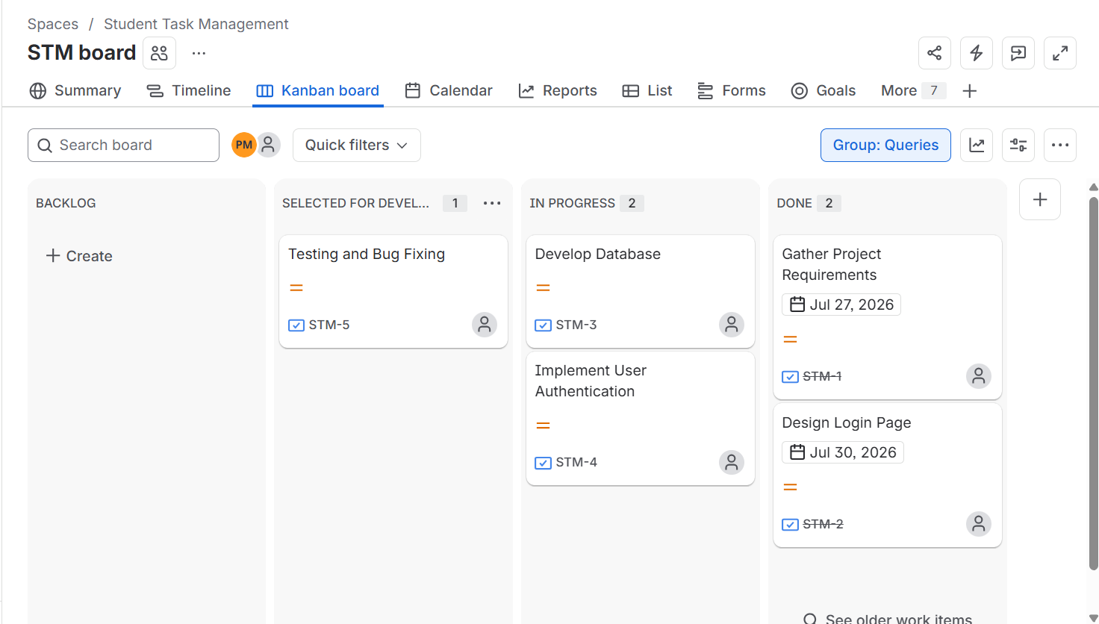
Figure 8. Moving Tasks Across Workflow Stages.

Observation
Task Name | Initial Status | Final Status
Gather Project Requirements | Backlog | Done
Design Login Page | Backlog | Done
Develop Database | Backlog | In Progress
Implement User Authentication | Backlog | Backlog
Testing and Bug Fixing | Backlog | Selected for Development

Result
The Kanban Board was successfully created using Jira Software. Five sample tasks were added and moved across different workflow stages to simulate a software development process. The experiment demonstrated how Jira helps teams visualize, organize, and track project progress efficiently.

Experiment No. 2
Sketch a Simple Prototype of a Bus Ticket Booking System using Figma Tool

Aim
To design a simple prototype of a Bus Ticket Booking System using the Figma tool by creating user interface screens and connecting them through prototype interactions.

Software Requirements
Software | Version
Figma | Web Application
Web Browser | Google Chrome / Microsoft Edge
Internet Connection | Required

Theory
Figma is a cloud-based user interface (UI) and user experience (UX) design tool widely used for designing websites, mobile applications, and software prototypes. It enables designers and developers to collaborate in real time, making the design process faster and more efficient.
A prototype is a visual representation of an application that demonstrates how users interact with different screens before the actual software is developed. Prototyping helps identify design improvements, reduces development errors, and improves the overall user experience.
In software engineering, Figma is commonly used to create wireframes, UI designs, and interactive prototypes. By connecting screens through clickable interactions, developers and stakeholders can visualize the application's workflow before implementation.

Procedure
Step 1: Open Figma
Open any web browser.
Navigate to the Figma website.
Sign in using your Figma account credentials.
After successful login, the Figma dashboard will be displayed.

Step 2: Create a New Design File
Click the New Design File button.
A blank design workspace will open.
Rename the file as Bus Ticket Booking System.

Step 3: Create Mobile Frames
Select the Frame Tool (F) from the toolbar.
Choose a mobile device frame such as Android Large or iPhone 14.
Create six separate mobile frames.
Arrange all frames horizontally for better organization.

Step 4: Design the Splash Screen
Create the first screen containing the following components:
- Application Logo
- Bus Image or Icon
- Application Title
- Welcome Message
- Get Started Button
This screen introduces the application to the user.

Step 5: Design the Login Screen
Create the login interface with the following components:
- Username Text Field
- Password Text Field
- Login Button
- Forgot Password Link
- Sign Up Link
This screen allows users to log into the application.

Step 6: Design the Home Screen
Design the main booking page containing:
- Source Location
- Destination Location
- Journey Date
- Number of Passengers
- Search Button
This screen enables users to search for available buses.

Step 7: Design the Search Bus Screen
Display a list of available buses. Each bus should contain:
- Bus Name
- Departure Time
- Ticket Price
- Book Now Button
This screen allows users to select a preferred bus.

Step 8: Design the Seat Selection Screen
Create a simple seat layout using square shapes. Include:
- Available Seats
- Selected Seat
- Confirm Booking Button
This screen enables users to select their desired seat before booking.

Step 9: Design the Booking Confirmation Screen
Create the final screen displaying booking information. Include:
- Booking Successful Message
- Passenger Name
- Bus Name
- Seat Number
- Journey Date
- Download Ticket Button
- Home Button
This screen confirms that the ticket has been successfully booked.

Step 10: Create Prototype Connections
Open the Prototype tab.
- Connect the Get Started button to the Login Screen.
- Connect the Login button to the Home Screen.
- Connect the Search button to the Search Bus Screen.
- Connect the Book Now button to the Seat Selection Screen.
- Connect the Confirm Booking button to the Booking Confirmation Screen.
- Connect the Home button back to the Home Screen.
These connections simulate the complete user workflow.

Step 11: Run the Prototype
Click the Present button.
- Test every button by clicking it.
- Verify that each screen navigates correctly.
- Ensure the complete booking process functions smoothly from the Splash Screen to the Booking Confirmation Screen.

Observation
Screen Name | Components Designed | Prototype Link Status
Splash Screen | Logo, Title, Get Started Button | Linked to Login Screen
Login Screen | Username, Password, Login Button | Linked to Home Screen
Home Screen | Source, Destination, Date, Search Button | Linked to Search Bus Screen
Search Bus Screen | Bus List, Book Now Button | Linked to Seat Selection Screen
Seat Selection Screen | Seat Layout, Confirm Booking Button | Linked to Booking Confirmation Screen
Booking Confirmation Screen | Booking Details, Home Button | Linked back to Home Screen

Result
A simple prototype of the Bus Ticket Booking System was successfully designed using Figma. Six mobile screens were created and connected through prototype interactions to simulate the complete user journey, from the Splash Screen to the Booking Confirmation Screen. The experiment demonstrated how Figma helps visualize an application's workflow before actual development begins.

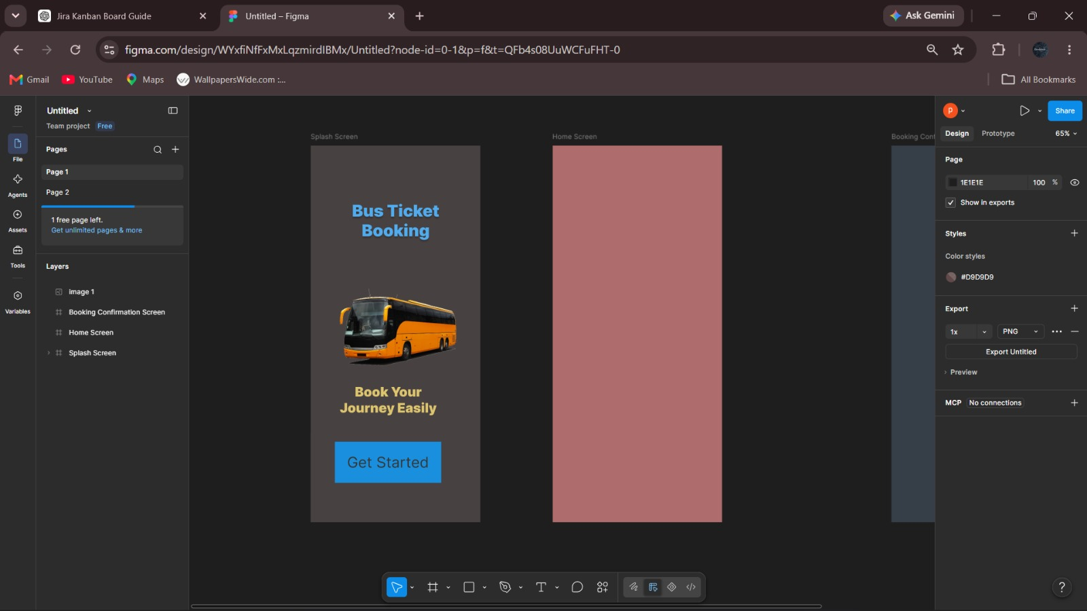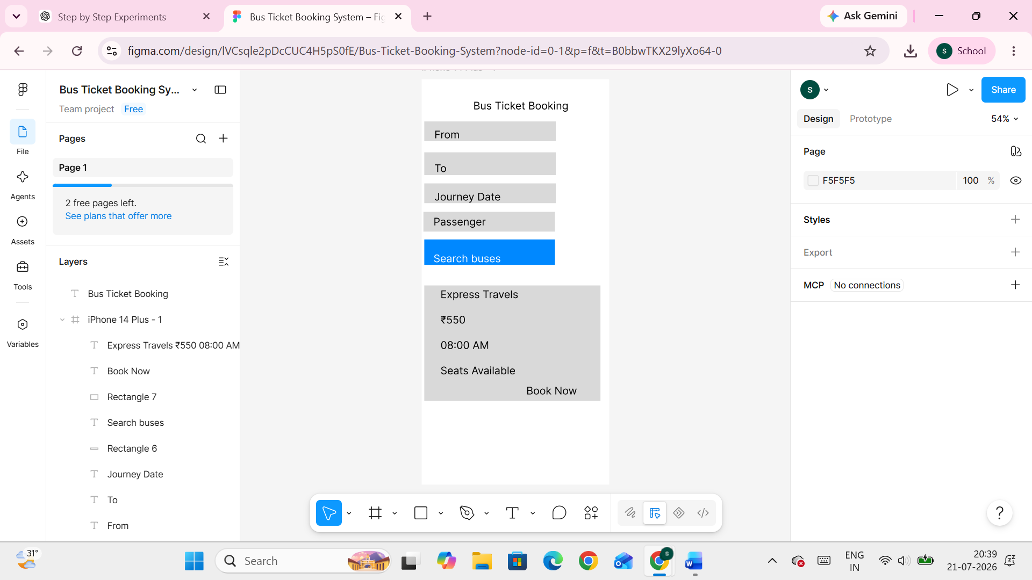

Experiment No. 3
Design an E-Commerce Mobile Application Prototype using Figma

Aim
To design and connect a simple prototype of an E-Commerce Mobile Application named ShopEase using the Figma tool, demonstrating the complete user journey from the Welcome Screen to the Order Confirmation Screen.

Software Requirements
Software | Version
Figma | Web Application
Web Browser | Google Chrome / Microsoft Edge
Internet Connection | Required

Theory
Figma is a cloud-based UI/UX design tool that allows designers to create wireframes, screen designs, and interactive prototypes that can be shared and reviewed in real time. It is widely used to design mobile and web applications before development begins.
A clickable prototype connects individual screens using defined interactions, allowing stakeholders to experience the application's navigation flow as if it were a working product. This helps identify usability issues early and reduces costly changes later in development.
In an e-commerce application, prototyping the journey from browsing products to completing a purchase helps validate that the checkout flow is intuitive and that all essential screens, such as login, product details, and order confirmation, work together seamlessly.

Procedure
Step 1: Open Figma
1. Open a web browser.
2. Navigate to the Figma website.
3. Sign in using your Figma account.
4. Click New Design File to create a new project.

Step 2: Create a New Design File
1. Rename the design file as E-Commerce Mobile App Prototype.
2. Select the Frame Tool (F) from the toolbar.
3. Choose a mobile device frame (Android Large or iPhone 14).
4. Create six mobile frames for designing the application screens.

Step 3: Design the Welcome Screen
Create the first screen with the following components:
- Application Logo
- Application Name (ShopEase)
- Welcome Message
- Get Started Button
This screen serves as the entry point of the application.

Step 4: Design the Login Screen
Create the Login screen containing:
- Email Address field
- Password field
- Login Button
- Sign Up Link
This screen allows users to authenticate before accessing the application.

Step 5: Design the Home Screen
Design the Home screen with the following elements:
- Search Bar
- Product Categories
- Featured Products
- Bottom Navigation Bar
This screen provides users with easy access to products and categories.

Step 6: Design the Product Details Screen
Create a Product Details screen displaying:
- Product Image
- Product Name
- Product Price
- Product Description
- Add to Cart Button
This screen enables users to view detailed information about a selected product.

Step 7: Design the Shopping Cart Screen
Design the Shopping Cart screen containing:
- Selected Product List
- Quantity Selector
- Total Price
- Checkout Button
This screen allows users to review their selected products before placing an order.

Step 8: Design the Order Confirmation Screen
Create the final screen displaying:
- Order Successfully Placed message
- Order ID
- Thank You Message
- Continue Shopping Button
This screen confirms the successful completion of the purchase.

Step 9: Create Prototype Connections
Select the Prototype tab in Figma. Connect the screens using navigation links as follows:
- Welcome Screen → Login Screen
- Login Screen → Home Screen
- Home Screen → Product Details Screen
- Product Details Screen → Shopping Cart Screen
- Shopping Cart Screen → Order Confirmation Screen
Set the interaction type to On Click → Navigate To for each button.

Step 10: Preview the Prototype
1. Click the Present button.
2. Navigate through the prototype by clicking the buttons.
3. Verify that all screens are connected correctly and the navigation works as expected.

Observation
Screen Name | Key Components | Connected To
Welcome Screen | Logo, App Name, Get Started Button | Login Screen
Login Screen | Email, Password, Login Button | Home Screen
Home Screen | Search Bar, Categories, Featured Products | Product Details Screen
Product Details Screen | Product Info, Add to Cart Button | Shopping Cart Screen
Shopping Cart Screen | Product List, Total Price, Checkout Button | Order Confirmation Screen
Order Confirmation Screen | Order ID, Thank You Message | —

Result
A prototype of the E-Commerce Mobile Application was successfully designed using the Figma tool. The prototype demonstrated the complete user flow from the Welcome Screen to the Order Confirmation Screen. The design was presented to stakeholders to gather feedback and obtain approval before proceeding with the application development phase.
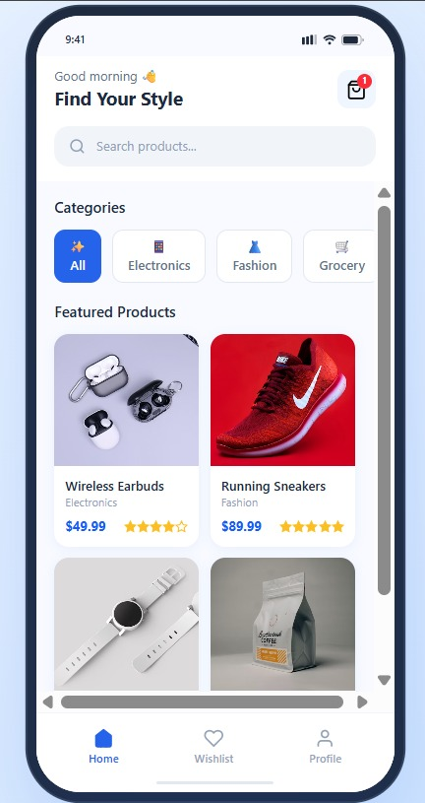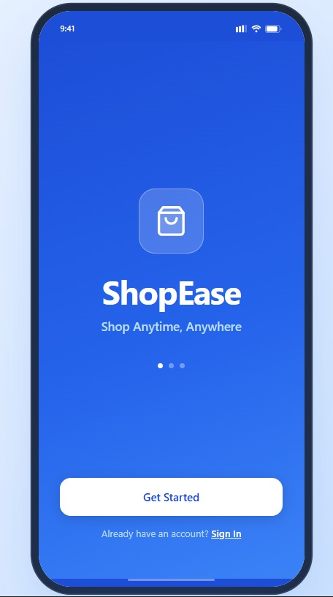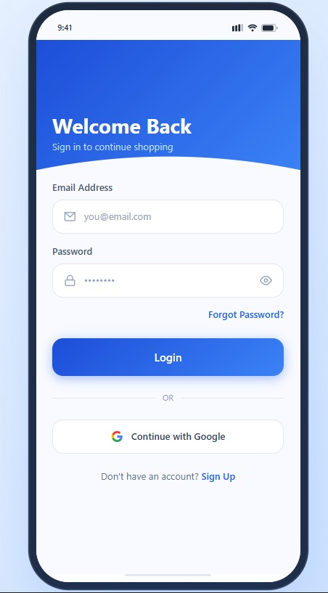

Experiment No. 4
The string is a sequence of characters placed in double quotes (” “). Performing different operations on string data is called String Handling. Strings are immutable. Whenever a change to a String is made, an entirely new String is created. If we want to store a group of characters we can use a char array. String provides various methods to perform different operations on strings. Using Raptor draw a flowchart to display the total number of characters in the string and returns it.

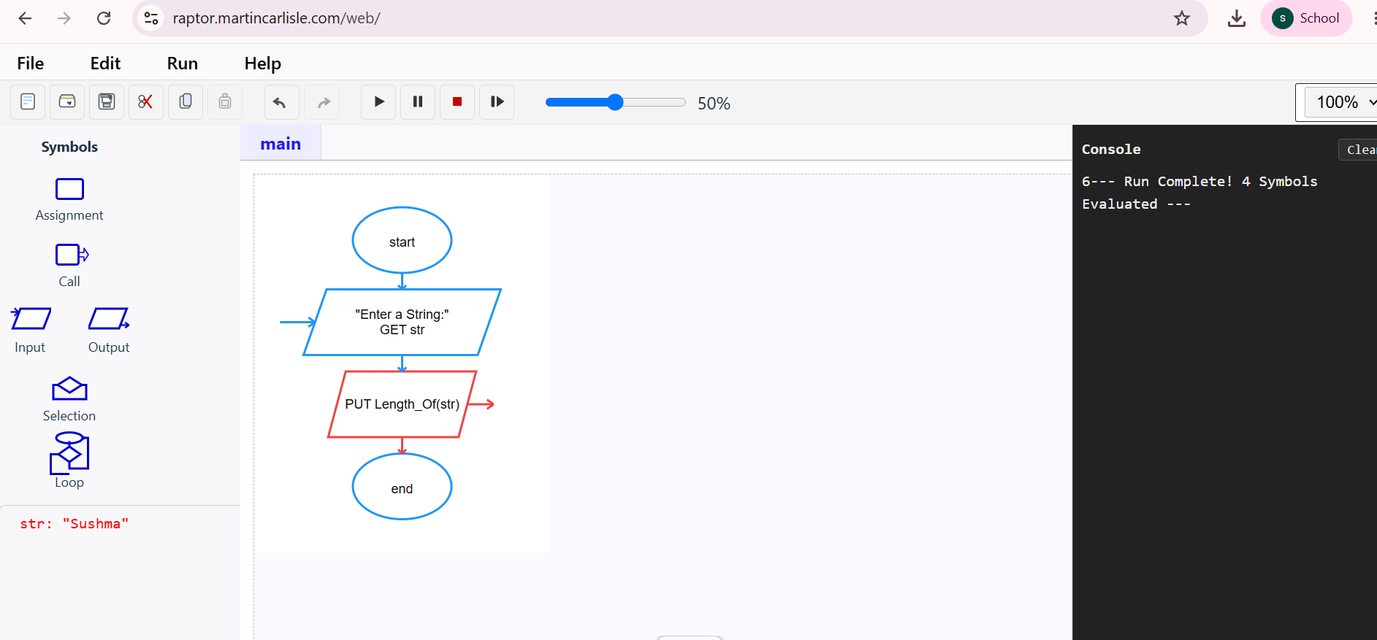

Experiment No. 05
Using Raptor – Draw and validate a flowchart for a given string of lower case English alphabets.
One can choose any two characters in the string and replace all the occurrences of the first character with the second character and replace all the occurrences of the second character with the first character. Using Raptor draw and validate the flowchart lexicographically smallest string that can be obtained by doing this operation at most once.

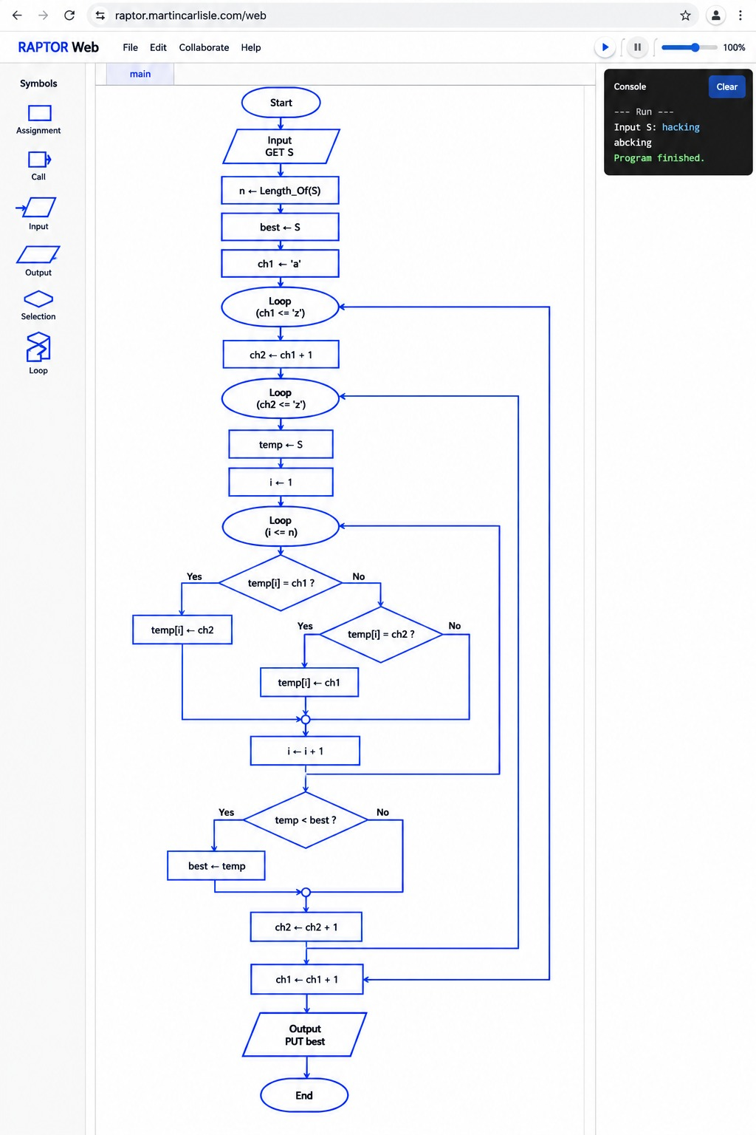

Experiment No. 6
An online food delivery platform enables customers to browse restaurants, view menus, place food orders, make online payments, and track delivery status. Restaurants use the system to manage their menus and update order status, while delivery agents are responsible for accepting delivery requests and updating delivery progress. Design a Class Diagram, Use case Diagram and Activity Diagram for the Online Food Delivery System showing the relevant classes, their attributes, methods, and relationships.
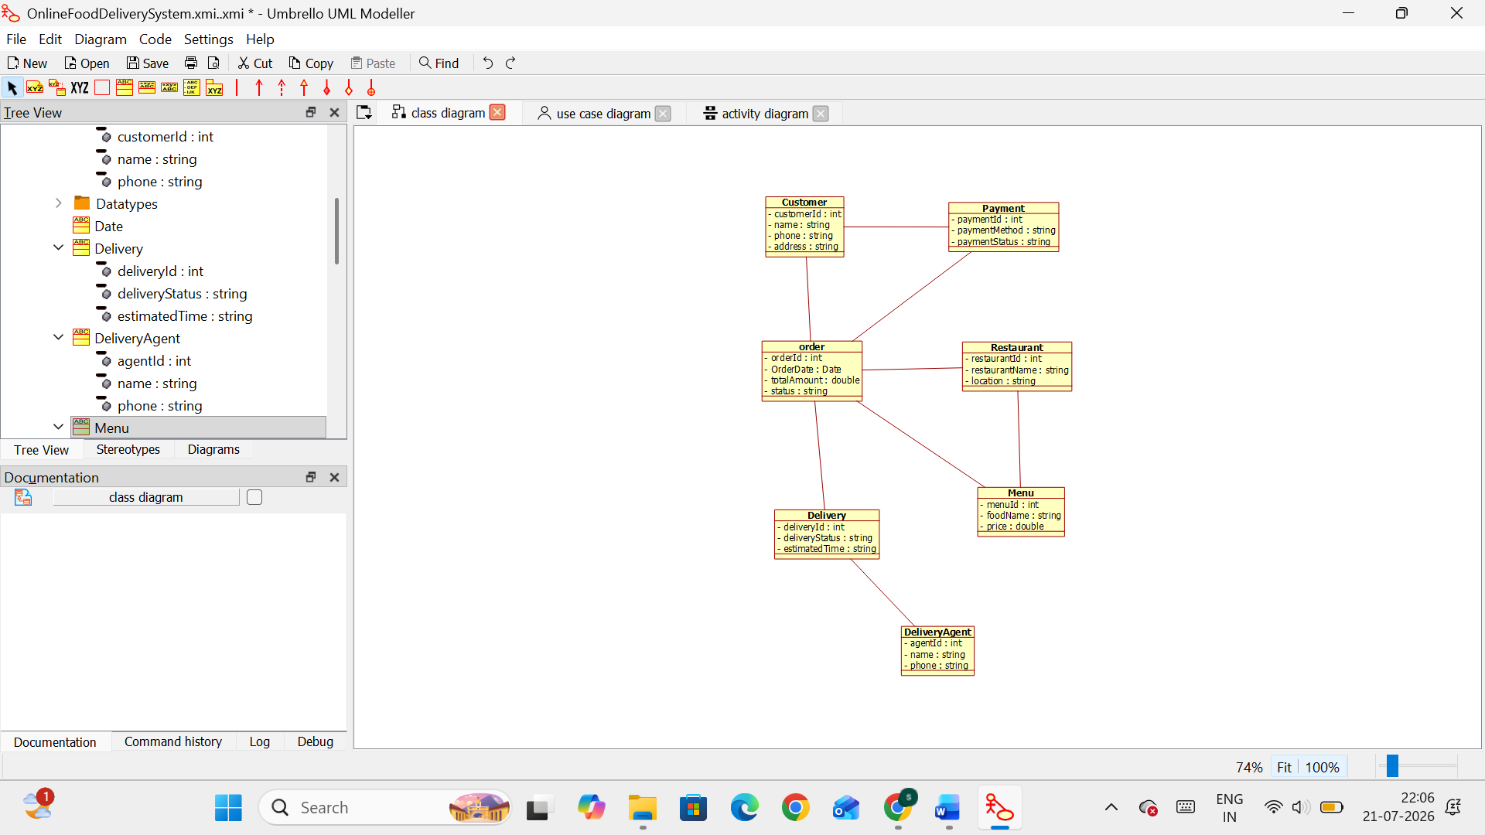

Experiment No. 07
A college employs a large number of security personnel who are assigned duties at various locations across the campus. Each security person follows a duty schedule that includes date, duty start time, duty end time, and assigned location, ensuring that every campus location is covered. If a security person takes leave, it is recorded manually, and at the end of each month, salaries are calculated based on duties performed and leaves taken. Since manual handling of duty allocation, leave management, and salary calculation is time-consuming and complex, the college plans to develop an Online Security Management System to automate these activities. Develop Class Diagram, Use case Diagram and Activity Diagram to represent the workflow of the Online Security Management System.
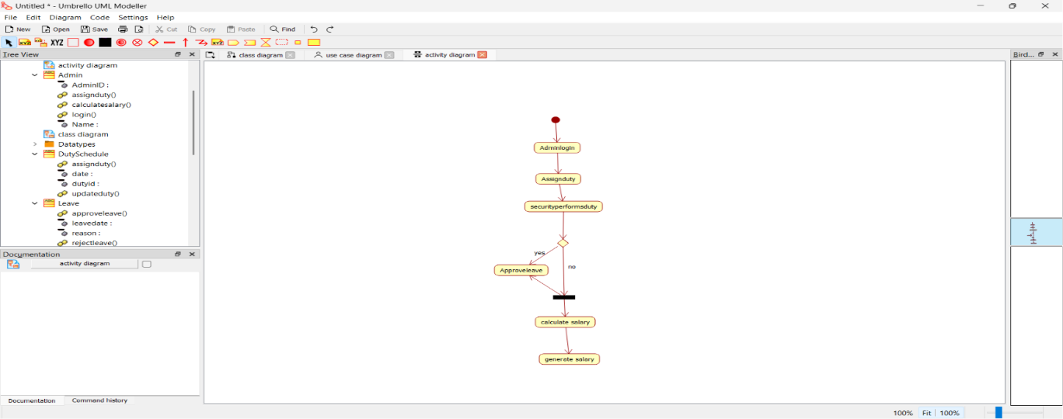

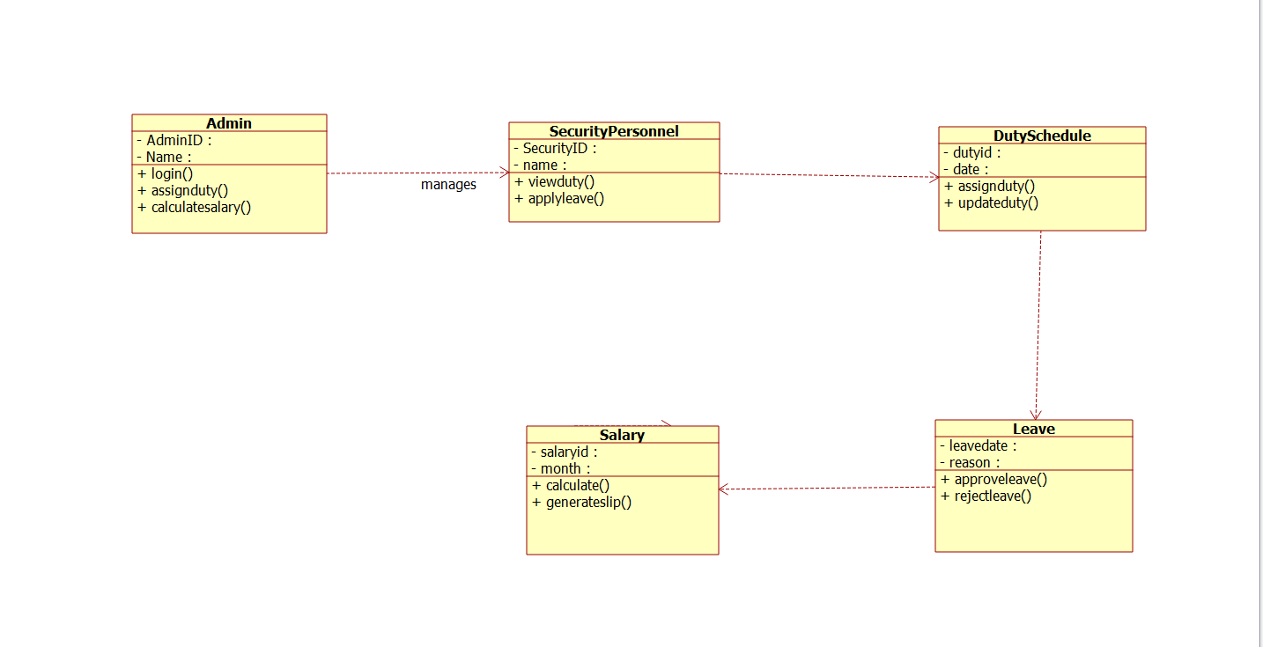
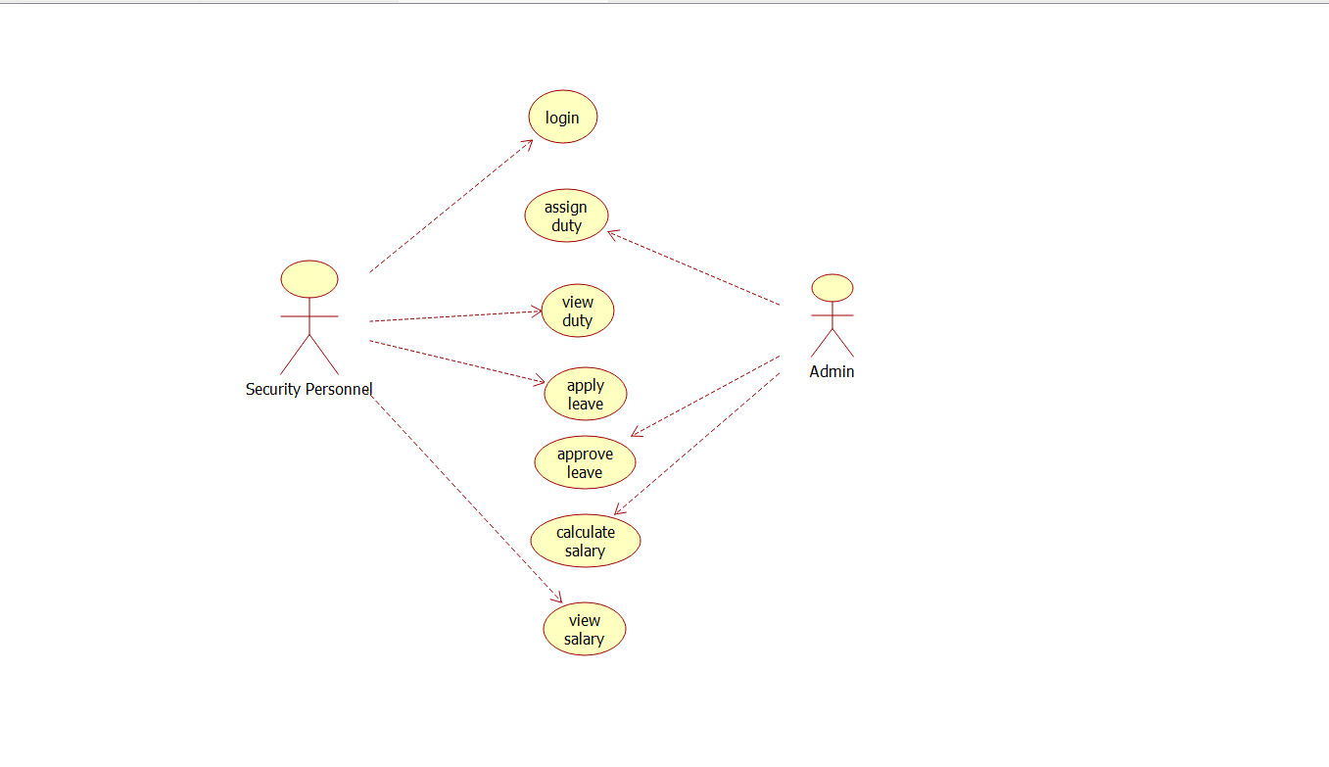

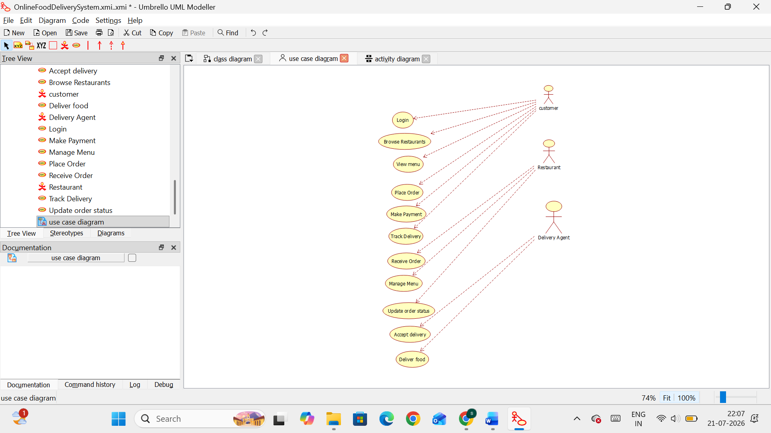

Experiment No. 08
Cyclomatic Complexity in Software Testing is a testing metric used for measuring the complexity of a software program. It is a quantitative measure of independent paths in the source code of a software program. Cyclomatic complexity can be calculated by using control flow graphs or with respect to functions, modules, methods or classes within a software program. Cyclomatic complexity for a flow graph G is V(G)=E-N+2. Cyclomatic complexity is a software metric (measurement), used to indicate the complexity of a program, Cyclomatic complexity = E - N + P where, E = number of edges in the flow graph, N = number of nodes in the flow graph, P = number of nodes that have exit points. Find Cyclomatic Complexity for a graph having number of edges as 17, number of nodes as 13 and number of predicate nodes in the flow graph as 5.

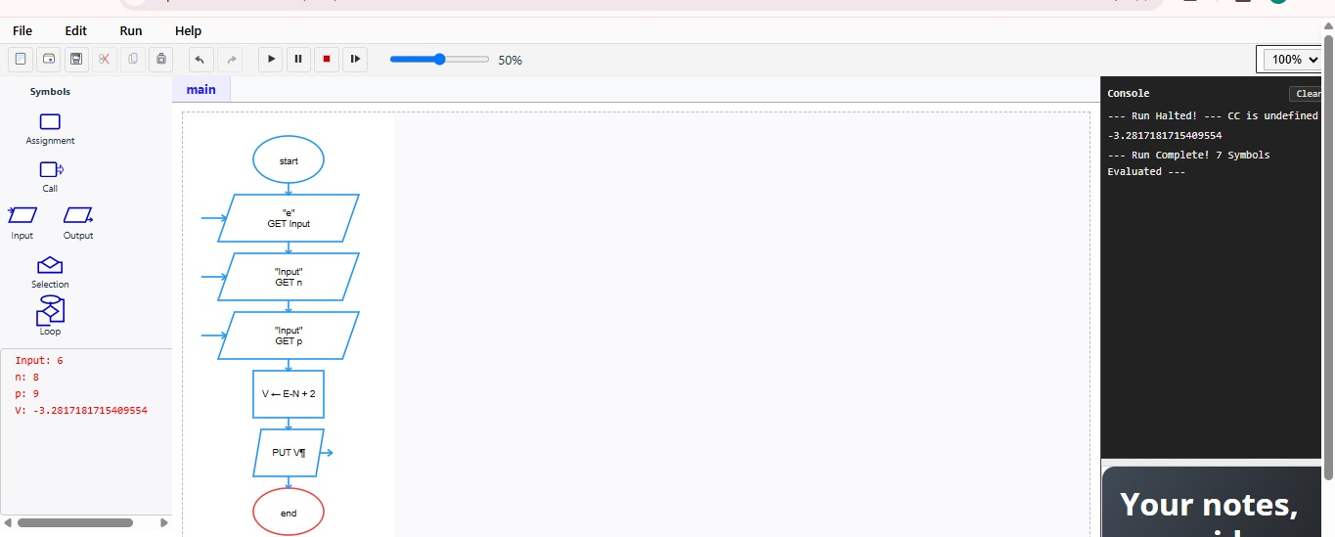

Experiment No. 09
Create a Scrum Project in Jira

Aim
To create a Scrum project in Jira, add backlog items, prioritize them, create a one-week sprint, move the backlog items into the sprint, and start the sprint to simulate the Scrum development process.

Software Requirements
Software | Version
Jira Cloud | Web Application
Web Browser | Google Chrome / Microsoft Edge
Internet Connection | Required

Theory
Scrum is an agile framework used in software development to manage and complete complex projects through short, time-boxed iterations known as sprints. It emphasizes iterative progress, collaboration, and continuous feedback among team members.
A Product Backlog is a prioritized list of features, tasks, or requirements that need to be completed during the course of a project. A Sprint is a fixed time period, typically one to four weeks, during which a selected set of backlog items is developed and delivered.
In Software Engineering, Jira supports the Scrum framework by allowing teams to create backlogs, plan sprints, and track task progress on a Sprint Board. This helps teams deliver working software incrementally while maintaining flexibility to adapt to changing requirements.

Procedure
Step 1: Create a Scrum Project
1. Log in to Jira Cloud.
2. Click Create Space.
3. Select Software Development.
4. Choose the Scrum template.
Enter the following project details:
Field | Value
Project Name | Online Shopping System
Management Type | Company-managed
Project Key | OSS

Click Create.

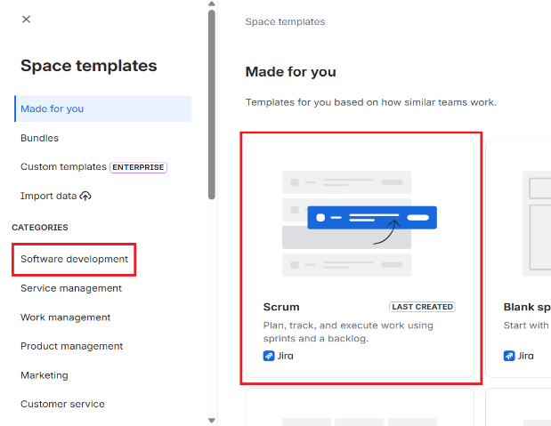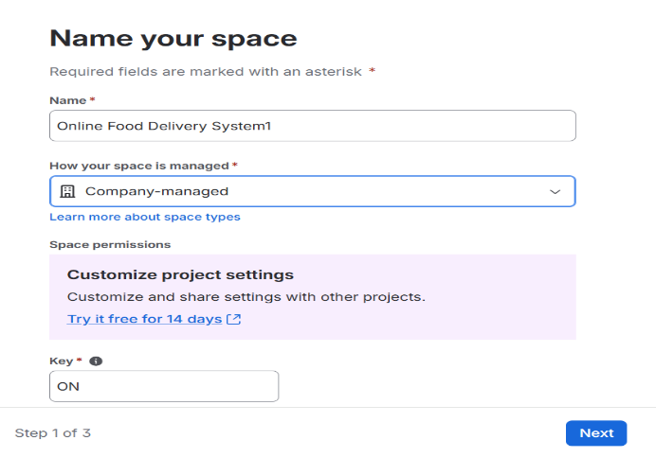
Figure 1. Creating a Scrum Project.
Step 2: Create Product Backlog
Open the Backlog section and create the following backlog items.
Priority | Backlog Item
High | Create User Registration Page
High | Develop Login API
Medium | Design Product Listing Page
Medium | Implement Shopping Cart
Low | Test Checkout Module

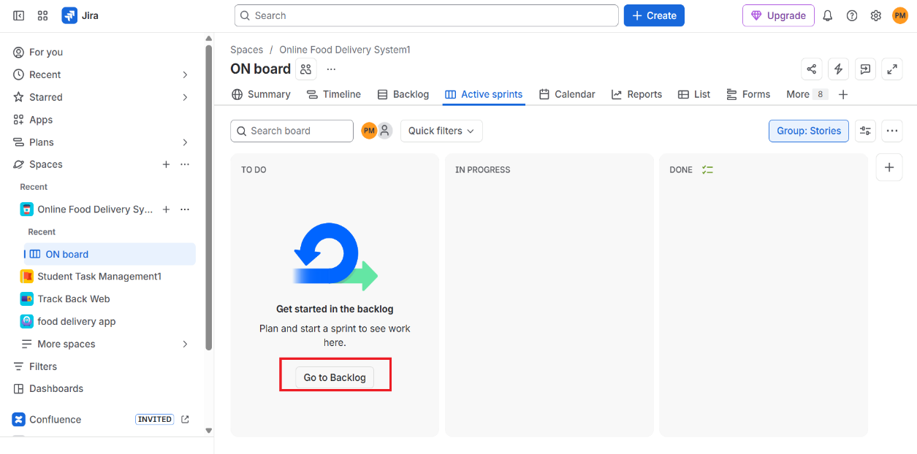
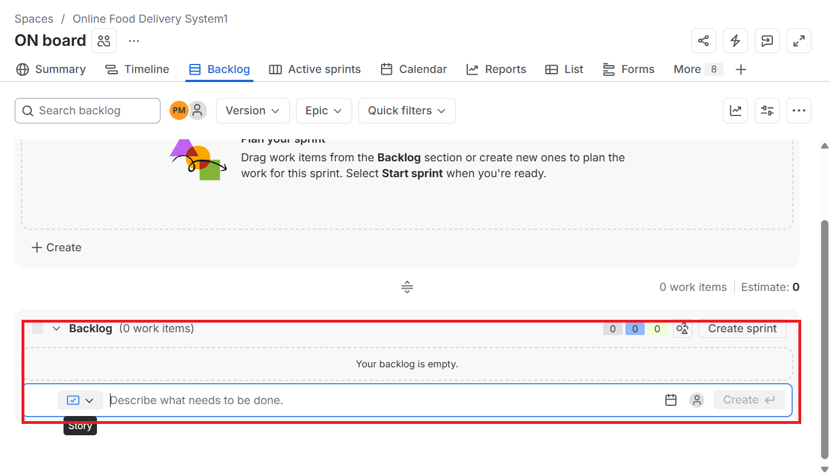
Figure 2. Creating Product Backlog Items.
Step 3: Prioritize the Backlog
Arrange the backlog in the following order:
1. Create User Registration Page
2. Develop Login API
3. Design Product Listing Page
4. Implement Shopping Cart
5. Test Checkout Module
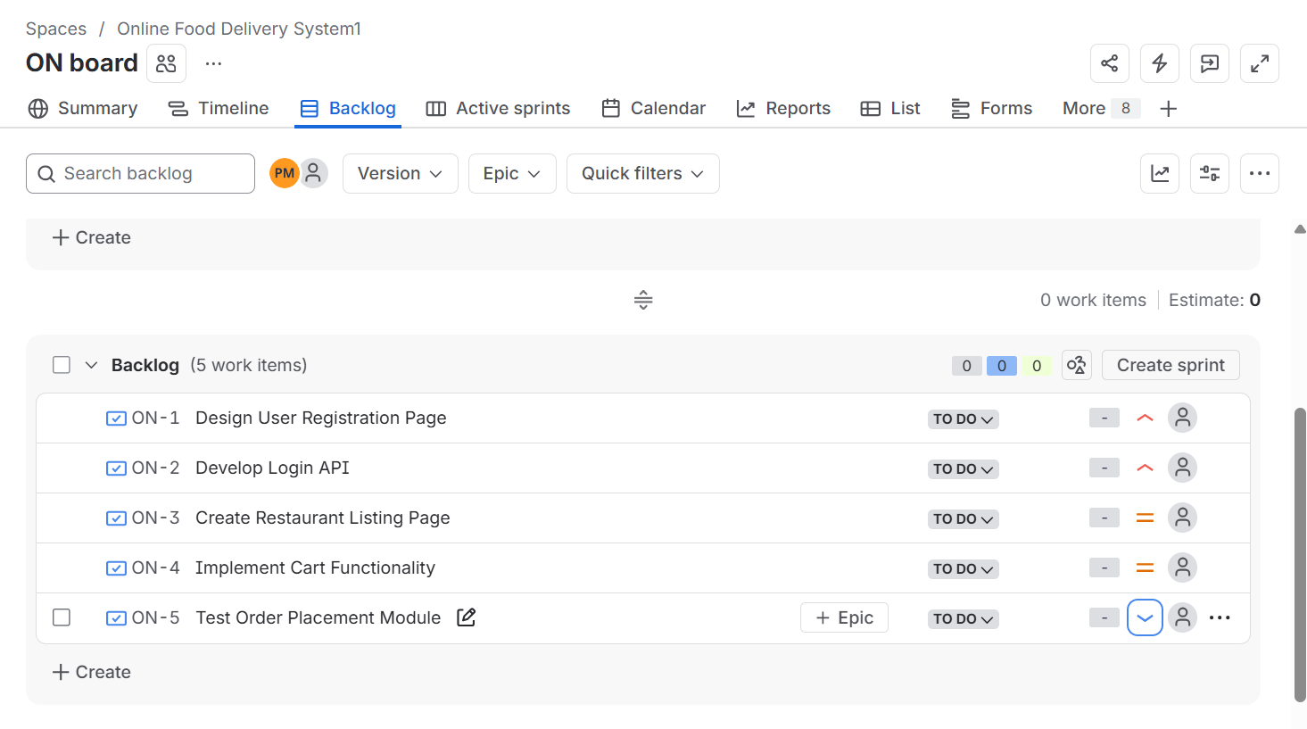
Figure 3. Prioritizing the Backlog.
Step 4: Create a Sprint
Click Create Sprint.
Enter the following details:
Field | Value
Sprint Name | Sprint 1
Duration | 1 Week

Save the sprint.
Figure 4. Creating Sprint 1.
Step 5: Add Backlog Items to Sprint
Move all five backlog items into Sprint 1.
Sprint Backlog:
- Create User Registration Page
- Develop Login API
- Design Product Listing Page
- Implement Shopping Cart
- Test Checkout Module
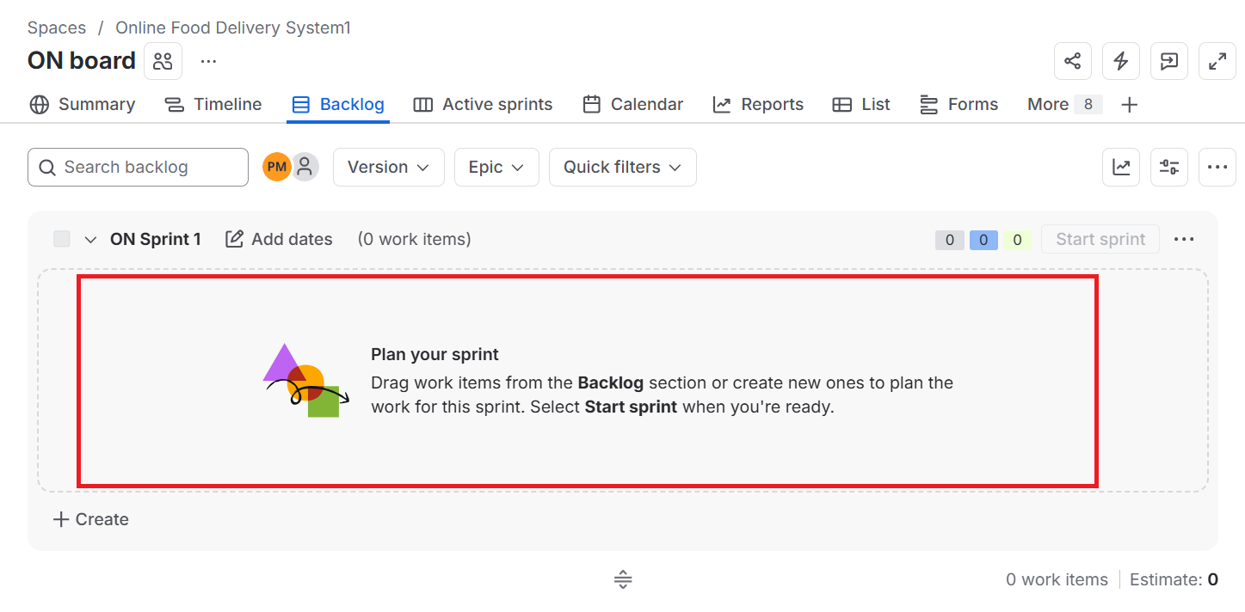
Figure 5. Adding Backlog Items to Sprint.
Step 6: Start the Sprint
1. Click Start Sprint.
2. Confirm the sprint duration is 1 Week.
3. Click Start.
The Sprint Board will display all tasks under the To Do column.
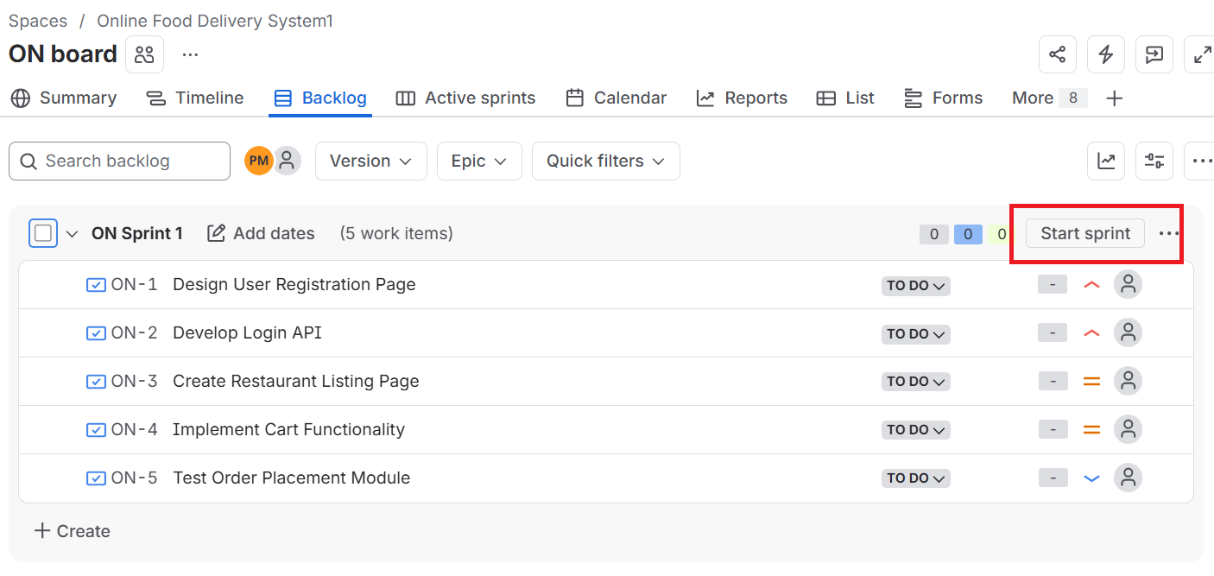
Figure 6. Starting the Sprint.
Step 7: Update Sprint Progress
Move the tasks to simulate development.
Task | Status
Create User Registration Page | Done
Develop Login API | Done
Design Product Listing Page | In Progress
Implement Shopping Cart | To Do
Test Checkout Module | To Do

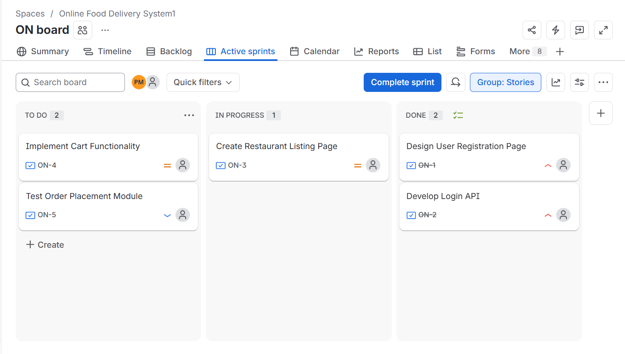
Figure 7. Updating Sprint Progress.
Step 8: Sprint Completion
The Sprint Board should display the following status:
Done
- Create User Registration Page
- Develop Login API
In Progress
- Design Product Listing Page
To Do
- Implement Shopping Cart
- Test Checkout Module
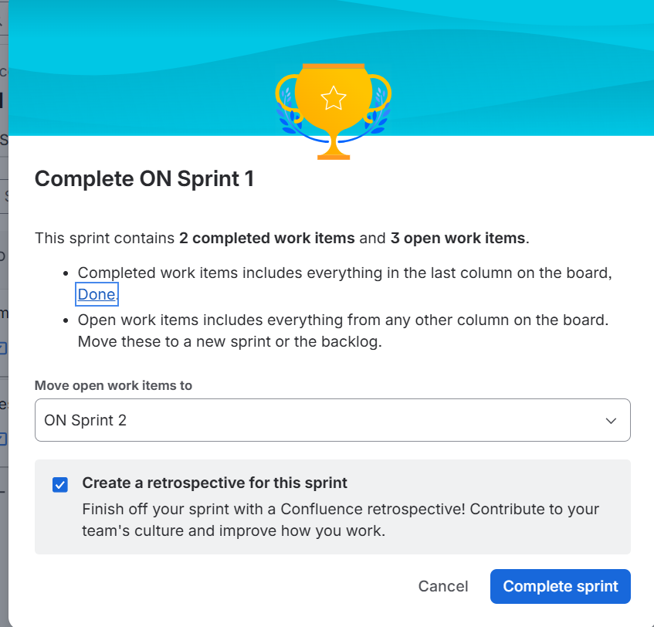
Figure 8. Sprint Completion Status.

Observation
Sprint Name | Total Tasks | Completed | In Progress | Pending
Sprint 1 | 5 | 2 | 1 | 2

Result
A Scrum project named Online Shopping System was successfully created in Jira. Five backlog items were added and prioritized, a one-week sprint was created, backlog items were assigned to the sprint, and the sprint was started successfully. The Sprint Board effectively demonstrated task progression using the Scrum workflow.

Experiment No. 10
Prioritize Software Requirements using the MoSCoW Method for a Library Management System

Aim
To analyze and categorize the functional requirements of a Library Management System using the MoSCoW Prioritization Method, based on user impact, feasibility, budget, and resource availability.

Software Requirements
Software | Version
Microsoft Excel / Google Sheets | Desktop Application

Theory
MoSCoW is a requirement prioritization technique used in software engineering to classify project requirements based on their importance and urgency. The name is derived from the first letters of its four categories: Must-Have, Should-Have, Could-Have, and Won't-Have, with the 'o's added simply to make the acronym pronounceable.

Procedure
Step 1: Identify the Requirements
Read the given requirements for the Library Management System carefully and understand the functionality expected in the software.

Step 2: Create a New Spreadsheet
Open Microsoft Excel or Google Sheets and create a new spreadsheet.

Step 3: Create Table Headings
Create a table with the following columns:
- Requirement
- MoSCoW Category
- Justification

Step 4: List the Requirements
Enter all the given functional requirements of the Library Management System into the Requirement column. The requirements include:
- Search books by title and author
- Online book reservation system
- Monthly borrowed books report
- Email notifications for overdue books
- QR code scanning
- Librarian dashboard
- Book reviews and ratings
- Chatbot assistance
- Mobile application
- Multi-language support

Step 5: Analyze Each Requirement
Evaluate every requirement based on the following criteria:
- Impact on users and stakeholders
- Feasibility considering available time
- Budget limitations
- Resource availability

Step 6: Categorize Using the MoSCoW Method
Assign each requirement to one of the following categories:
- Must-Have (M): Essential features required for the system to function.
- Should-Have (S): Important features that improve the system but are not critical.
- Could-Have (C): Desirable features that can be implemented if sufficient resources are available.
- Won't-Have (W): Features that are excluded from the current release and may be considered in future versions.

Step 7: Provide Justification
For each categorized requirement, write a brief justification explaining why it was assigned to that MoSCoW category based on its importance and feasibility.

Step 8: Save the Spreadsheet
Save the completed spreadsheet with an appropriate file name such as: Library_Management_System_MoSCoW_Prioritization.xlsx

Step 9: Verify the Data
Review the spreadsheet to ensure that:
- All requirements are included.
- Each requirement has an appropriate MoSCoW category.
- Every category has a clear and valid justification.
- The table is complete and properly formatted.

Observation
Requirement | MoSCoW Category | Justification
Search books by title and author | Must-Have | Core function required for the library system to be usable.
Librarian dashboard | Must-Have | Essential for librarians to manage books, users, and records.
Online book reservation system | Should-Have | Improves user convenience but the system can function without it initially.
Monthly borrowed books report | Should-Have | Useful for tracking usage, though not critical for day-to-day operation.
Email notifications for overdue books | Should-Have | Improves user experience and reduces overdue books, but not core functionality.
QR code scanning | Could-Have | Adds convenience for checkout but is not essential to core operations.
Book reviews and ratings | Could-Have | Enhances user engagement but has low impact on core library functions.
Mobile application | Could-Have | Desirable for accessibility but requires significant additional resources.
Chatbot assistance | Won't-Have | Low priority given current budget and time constraints; can be considered later.
Multi-language support | Won't-Have | Not essential for the initial release; deferred to a future version.

Result
The requirements of the Library Management System were successfully analyzed and categorized using the MoSCoW Prioritization Method. Each requirement was assigned to the appropriate priority level with a suitable justification based on user impact and project feasibility. The categorized requirements were documented in an Excel spreadsheet successfully.
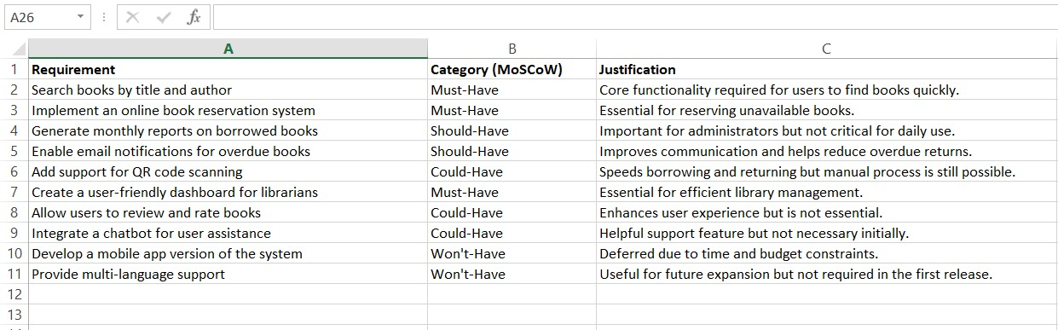

Experiment No. 11
Link Jira Tasks with Confluence for Library Management System

Aim
To integrate Jira work items with Confluence for the Library Management System project, enabling centralized task tracking, status monitoring, and visualization of sprint progress through embedded Jira issues and a progress indicator.

Software Requirements
Software | Version
Jira Cloud | Cloud Version
Confluence Cloud | Cloud Version
Google Chrome / Microsoft Edge | Latest Version

Theory
Confluence is a collaboration and documentation tool provided by Atlassian, while Jira is a project management and issue-tracking application. Integrating Jira with Confluence enables project teams to embed Jira work items directly into Confluence pages, providing real-time visibility of project progress.
The Jira macro displays issue details such as status, assignee, and priority, while a progress indicator helps monitor sprint completion efficiently. This integration improves communication, collaboration, and project documentation.

Procedure
Step 1: Create a Library Management System Project in Jira
- Log in to Jira Cloud.
- Click Create Space → Software Development.
- Select the Scrum template.
Enter the following details:
- Project Name: Library Management System
- Project Key: LMS
- Click Create.
Step 2: Create Jira Work Items
Open the Backlog and create the following Jira work items.
Issue ID | Summary | Status
LMS-1 | Develop Book Search Functionality | Done
LMS-2 | Create User Login Page | In Progress
LMS-3 | Implement Book Borrowing Module | To Do
LMS-4 | Design Librarian Dashboard | In Progress
LMS-5 | Test Book Return Module | Done

Arrange the work items so that their statuses appear under To Do, In Progress, and Done.
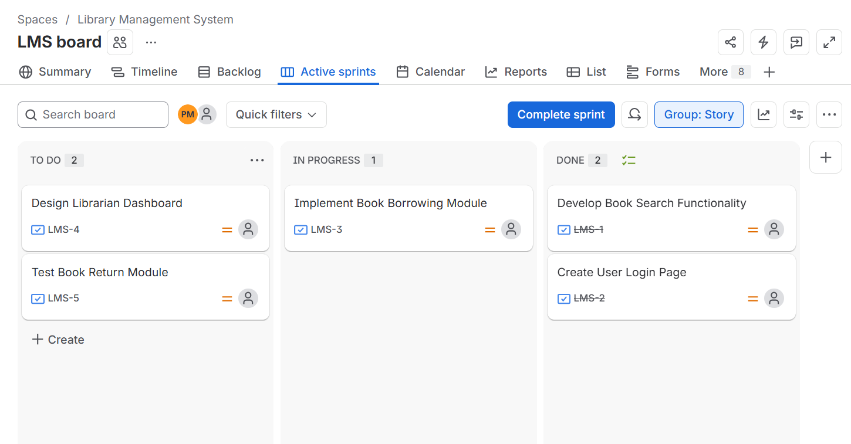

Step 3: Open Confluence
- Open your Atlassian Workspace.
- Select Confluence.
- Click Create to create a new page.
Step 4: Create a New Confluence Page
Create a page with the title: "Library Management System Project Overview"
Step 5: Add the Project Description
Below the page title, enter the following description:
"The Library Management System project is designed to automate library operations such as user login, book searching, borrowing, and returning books. This page provides an overview of the project tasks and tracks their current development status by integrating Jira work items into Confluence."
Step 6: Add a Heading
Create the heading: "Development Tasks"
Step 7: Insert Jira Work Items
- Place the cursor below the heading.
- Type /jira.
- Select Jira Work Items.
- Search for the Library Management System project.
Select the following Jira issues:
- LMS-1 – Develop Book Search Functionality
- LMS-2 – Create User Login Page
- LMS-3 – Implement Book Borrowing Module
- LMS-4 – Design Librarian Dashboard
- LMS-5 – Test Book Return Module
- Click Insert.
Verify that the embedded Jira work items display their current status (To Do, In Progress, and Done).
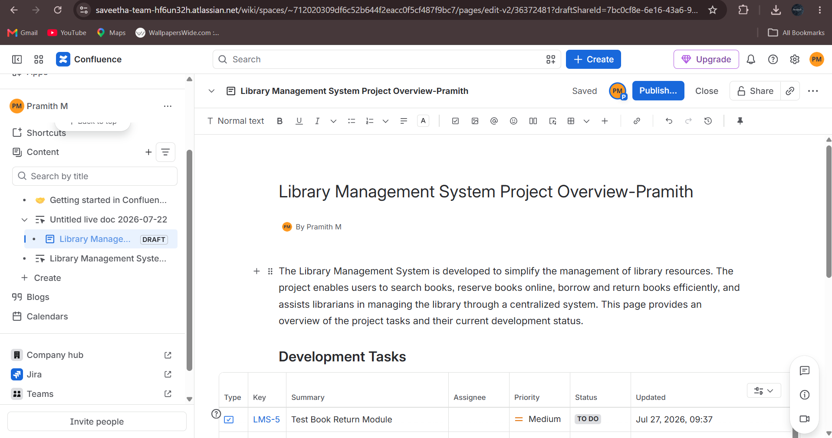

Step 8: Publish the Page
- Review the page contents.
Ensure that:
- The page title is correct.
- The project description is present.
- Five Jira work items are embedded.
- The task status is displayed correctly.
- The progress indicator is visible.
- Click Publish.
Step 9: Verify the Page
Review the published Confluence page to ensure that:
- The page title is displayed correctly.
- All five Jira work items are embedded successfully.
- Task statuses (To Do, In Progress, and Done) are visible.
- The progress indicator accurately reflects the sprint completion.
- The page is properly formatted.
- 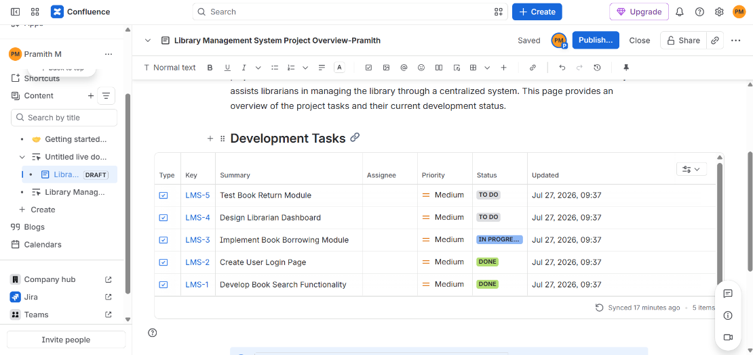

Figure 1. Library Management System Project Overview Page.

Observation
Embedded Jira Task | Status
Develop Book Search Functionality | Done
Create User Login Page | In Progress
Implement Book Borrowing Module | To Do
Design Librarian Dashboard | In Progress
Test Book Return Module | Done

Result
The Library Management System Project Overview page was successfully created in Confluence. Five Jira work items were embedded using the Jira macro, and their current status was displayed successfully. A progress indicator was added to visualize sprint completion, enabling efficient task tracking, collaboration, and progress monitoring throughout the project.

Experiment No. 12

You are designing a Task Management System for a small team. The system should include the following features:

- User Login and Role Assignment
- Task Creation and Assignment
- Task Prioritization and Deadlines
- Progress Tracking and Reporting
Prioritize these requirements using the MoSCoW and Kano models in Jira.

1. Objective
To design a Task Management System for a small team, identify and classify its requirements using the MoSCoW and Kano models, and implement this prioritization practically inside Jira using Epics, Stories, Labels, and a custom prioritization field.

2. System Overview
The Task Management System will support the following core features:
# | Feature
1 | User Login and Role Assignment
2 | Task Creation and Assignment
3 | Task Prioritization and Deadlines
4 | Progress Tracking and Reporting
Each feature will be broken into smaller requirements before prioritization.

3. Step 1 — Break Features into Detailed Requirements
Before prioritizing, expand each feature into specific requirements:
User Login and Role Assignment
- User registration/login with email and password
- Role-based access (Admin, Manager, Team Member)
- Password reset functionality
- Single Sign-On (SSO) (optional/future)
Task Creation and Assignment
- Create a task with title, description, attachments
- Assign task to one or more team members
- Reassign/transfer task ownership
- Bulk task creation via import
Task Prioritization and Deadlines
- Set priority levels (High/Medium/Low)
- Set due dates and reminders
- Auto-escalation of overdue tasks
- Drag-and-drop priority reordering
Progress Tracking and Reporting
- Task status updates (To Do, In Progress, Done)
- Dashboard with progress charts
- Exportable reports (PDF/Excel)
- Real-time notifications on status change

4. Step 2 — Apply the MoSCoW Model
MoSCoW classifies requirements into four categories:
Category | Meaning
M – Must Have | Critical; system fails without it
S – Should Have | Important but not critical; workaround exists
C – Could Have | Desirable; nice-to-have if time/resources permit
W – Won't Have (this time) | Out of scope for current release
Sample Classification
Requirement | MoSCoW Category
User login with role-based access | Must Have
Task creation and assignment | Must Have
Priority levels and deadlines | Must Have
Status tracking (To Do/In Progress/Done) | Must Have
Dashboard with progress charts | Should Have
Reminders/notifications | Should Have
Exportable reports | Could Have
Bulk task import | Could Have
Drag-and-drop reordering | Could Have
Single Sign-On (SSO) | Won't Have (this release)
Auto-escalation of overdue tasks | Won't Have (this release)

5. Step 3 — Apply the Kano Model
The Kano model classifies features by customer satisfaction impact:
Category | Description
Basic (Must-be) | Expected; absence causes dissatisfaction, presence isn't noticed
Performance | Satisfaction increases proportionally with functionality
Excitement (Delighters) | Unexpected features that create delight
Indifferent | Presence/absence doesn't affect satisfaction
Reverse | Presence actually causes dissatisfaction for some users
Sample Classification
Requirement | Kano Category
User login and authentication | Basic
Task creation and assignment | Basic
Priority and deadline setting | Performance
Progress dashboard/reports | Performance
Real-time notifications | Performance
Drag-and-drop reordering | Excitement
AI-based task suggestions (future) | Excitement
Dark mode UI | Indifferent
Overly aggressive escalation alerts | Reverse

6. Step 4 — Combine MoSCoW + Kano for Final Priority
Requirement | MoSCoW | Kano | Final Priority
Login & Role Assignment | Must | Basic | P1 – Release 1
Task Creation & Assignment | Must | Basic | P1 – Release 1
Priority & Deadlines | Must | Performance | P1 – Release 1
Status Tracking | Must | Performance | P1 – Release 1
Dashboard & Reports | Should | Performance | P2 – Release 2
Notifications | Should | Performance | P2 – Release 2
Drag-and-Drop Reorder | Could | Excitement | P3 – Release 3
Bulk Import | Could | Indifferent | P3 – Release 3
SSO | Won't | Excitement | Backlog

7. Step 5 — Implement Prioritization in Jira
7.1 Create the Project
- Log in to Jira → click Create Project.
- Choose template: Scrum or Kanban (Scrum recommended for release-based priority).
- Name the project "Task Management System" and set the project key (e.g., TMS).
7.2 Create Epics for Each Feature
- Go to Backlog → click Create Epic.
- Create 4 epics:
  - Epic 1: User Login and Role Assignment
  - Epic 2: Task Creation and Assignment
  - Epic 3: Task Prioritization and Deadlines
  - Epic 4: Progress Tracking and Reporting
7.3 Add User Stories Under Each Epic
- Click Create Issue → select Story.
- Link each story to its parent epic.
- Example: Under Epic 1 → "As a user, I want to log in with my email and password so I can access my dashboard."
7.4 Set Up MoSCoW Using Labels or a Custom Field
- Go to Project Settings → Fields → Add custom field.
- Create a field named MoSCoW Priority (type: Select List – single choice).
- Add options: Must Have, Should Have, Could Have, Won't Have.
- Apply this field to each story/issue.
7.5 Set Up Kano Classification
- Repeat the custom field process to create a Kano Category field.
- Options: Basic, Performance, Excitement, Indifferent, Reverse.
- Apply to each issue alongside MoSCoW.
7.6 Prioritize the Backlog
- In the Backlog view, drag issues to reorder based on combined MoSCoW + Kano priority (Must+Basic/Performance items at top).
- Use Jira's built-in Priority field (Highest/High/Medium/Low) to reflect this ordering for reporting.
7.7 Set Deadlines and Sprints
- Create Sprints (Release 1, Release 2, Release 3) matching your priority tiers.
- Drag Must Have/Basic stories into Sprint 1; Should Have into Sprint 2; Could Have into Sprint 3.
- Set Due Dates on each issue.
7.8 Track Progress and Generate Reports
- Go to Reports → select Burndown Chart or Sprint Report.
- Monitor task status changes on the Board view (To Do / In Progress / Done).

8. Conclusion
Using MoSCoW helped classify requirements by necessity (what must be built now vs. later), while the Kano model helped classify them by user satisfaction impact (basic expectations vs. delighters). Combining both gave a clear, defensible release plan, which was then implemented in Jira through Epics, Stories, custom fields, and sprint planning — allowing the team to track progress transparently via boards and reports.

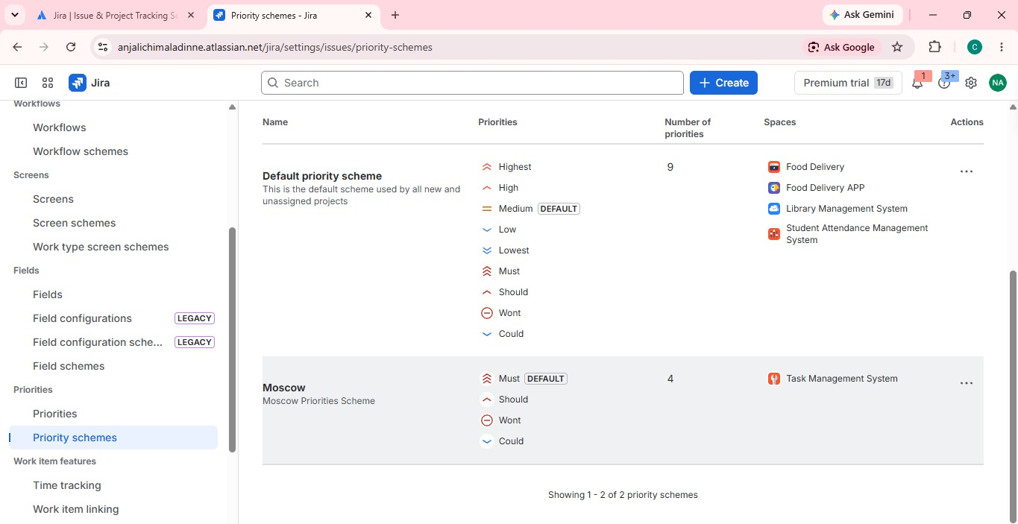
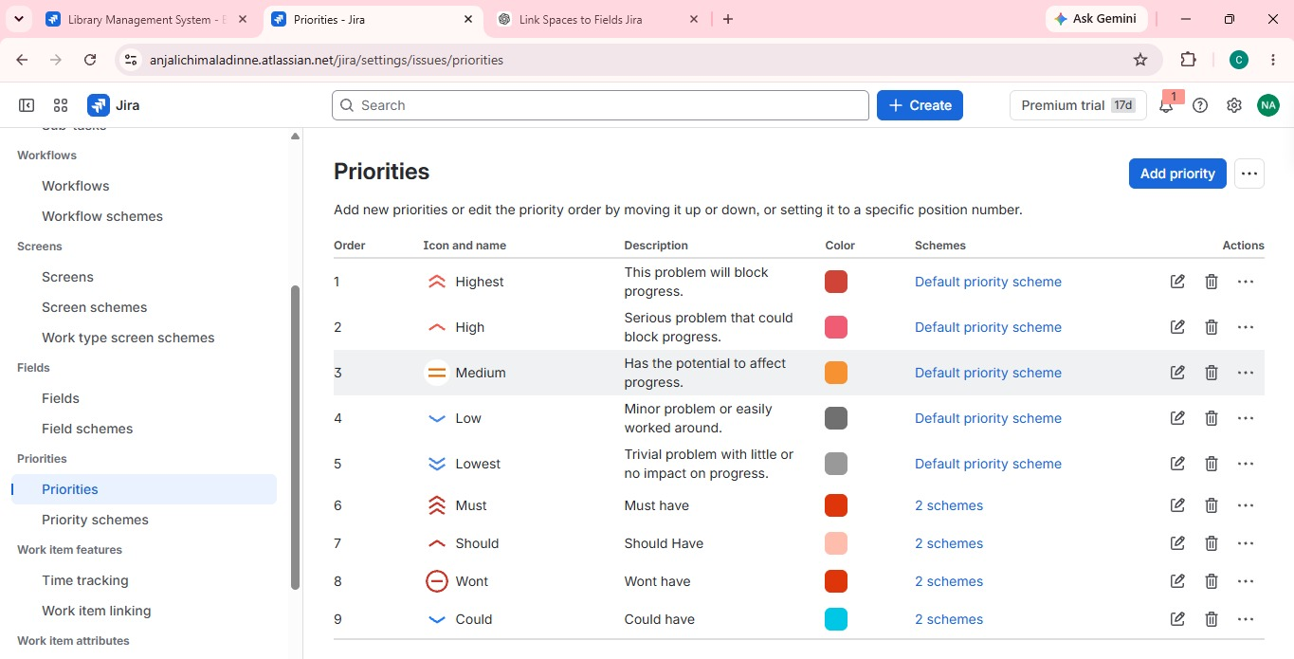

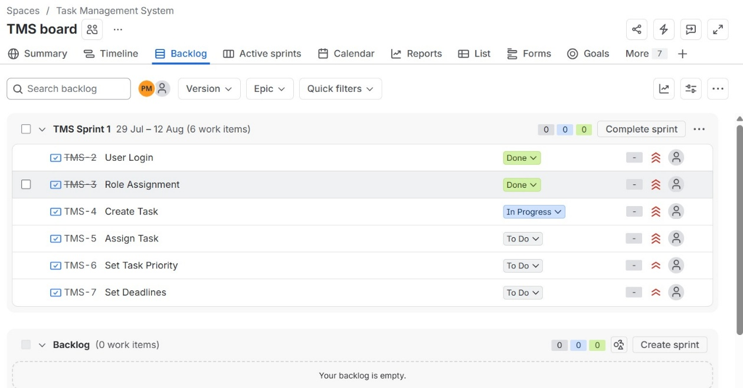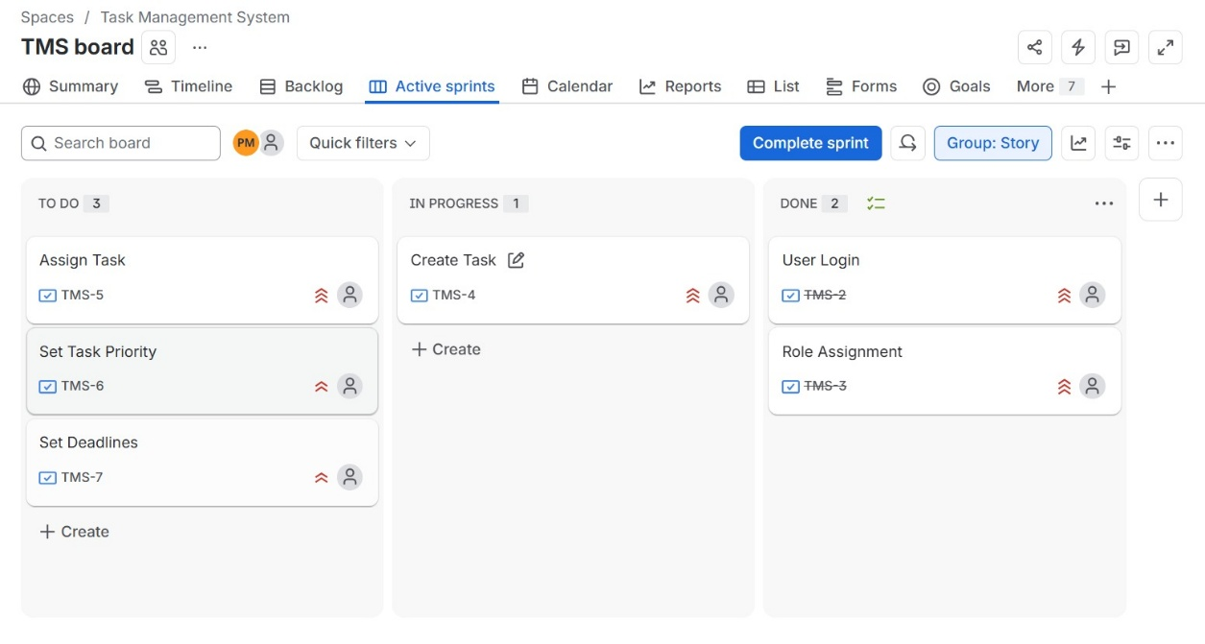

Experiment No. 13
You are tasked with developing an Online Learning Platform. The platform should include the following functionalities:

Course Enrollment and Registration

Video Lecture Streaming

Interactive Quizzes and Assignments

Progress Tracking Dashboard

Peer-to-Peer Discussion Forums

Certificate Generation
Use Jira to categorize and prioritize these requirements using MoSCoW and Kano techniques
Aim
To categorize and prioritize the functional requirements of an Online Learning Platform using the MoSCoW and Kano prioritization techniques, implemented through Jira software.
Software Required
Jira (Cloud version — jira.atlassian.com / your organization's Jira instance)
Requirements to be Prioritized
- Course Enrollment and Registration
- Video Lecture Streaming
- Interactive Quizzes and Assignments
- Progress Tracking Dashboard
- Peer-to-Peer Discussion Forums
- Certificate Generation

Part A: Theory
MoSCoW Technique
MoSCoW classifies requirements into four categories:
- Must Have — critical, non-negotiable for launch
- Should Have — important but not vital; can be delayed if needed
- Could Have — desirable but not necessary; nice-to-have
- Won't Have (this time) — out of scope for the current release
Kano Model
Kano classifies requirements based on customer satisfaction impact:
- Basic (Must-be) — expected by users; absence causes dissatisfaction
- Performance — satisfaction increases proportionally with how well it's implemented
- Excitement (Attractive) — unexpected features that delight users
- Indifferent — features users don't care about either way

Part B: Procedure in Jira
Step 1: Create a Jira Project
- Log in to Jira at your-domain.atlassian.net.
- Click "Create Project" on the left sidebar.
- Select template: Scrum or Kanban (Scrum is preferred for backlog prioritization).
- Name the project: "Online Learning Platform".
- Set the project key (e.g., OLP) and click Create.
Step 2: Create an Epic
- Go to the Backlog view.
- Click "Create" (top bar) → set Issue Type to Epic.
- Name the epic: "Online Learning Platform - Core Features".
- Click Create.
Step 3: Create Issues for Each Requirement
- In the Backlog, click "Create issue".
- Set Issue Type to Story.
- Enter the Summary field with each requirement, one at a time:
  - Course Enrollment and Registration
  - Video Lecture Streaming
  - Interactive Quizzes and Assignments
  - Progress Tracking Dashboard
  - Peer-to-Peer Discussion Forums
  - Certificate Generation
- Link each Story to the Epic created in Step 2 (use the Epic Link field).
- Click Create after each entry — this results in 6 stories under the epic.
Step 4: Set Up Custom Labels for MoSCoW
- Open each issue (Story) one at a time.
- On the right panel, find the Labels field.
- Click Add label and type one of the following (create new labels if they don't exist):
  - must-have
  - should-have
  - could-have
  - wont-have
- Assign labels based on the analysis below:
Requirement | MoSCoW Category | Justification
Course Enrollment and Registration | Must Have | Core entry point; platform cannot function without it
Video Lecture Streaming | Must Have | Primary content delivery mechanism
Interactive Quizzes and Assignments | Should Have | Important for learning outcomes, not blocking launch
Progress Tracking Dashboard | Should Have | Enhances user experience, not critical to MVP
Peer-to-Peer Discussion Forums | Could Have | Adds engagement but platform works without it
Certificate Generation | Could Have | Valuable add-on, can be released in a later version
Step 5: Set Up Custom Field for Kano Classification
- Go to Project Settings → Fields (Jira Admin access required).
- Click "Add Field" → choose Select List (single choice).
- Name the field: "Kano Category".
- Add options: Basic, Performance, Excitement, Indifferent.
- Attach this field to your project's issue screen.
- Go back to each Story and set its Kano Category value:
Requirement | Kano Category | Justification
Course Enrollment and Registration | Basic | Expected baseline; its absence causes major dissatisfaction
Video Lecture Streaming | Basic | Core expected functionality of any learning platform
Interactive Quizzes and Assignments | Performance | More/better quizzes = higher satisfaction
Progress Tracking Dashboard | Performance | Better tracking = more perceived value
Peer-to-Peer Discussion Forums | Excitement | Not expected by default; delights users when present
Certificate Generation | Excitement | Adds unexpected value (credibility, motivation)
Step 6: Prioritize the Backlog
- Go to the Backlog view.
- Drag and drop issues to reorder them — highest priority (Must Have + Basic) at the top.
- Use the Priority field (top-right of each issue) to also set: Highest, High, Medium, Low, aligned with the MoSCoW ranking.
Step 7: Create a Board View for Visualization
- Go to Project Settings → Board → Columns.
- Set up columns: To Do, In Progress, In Review, Done.
- Use Quick Filters (Board settings) to filter issues by label, e.g., filter by must-have to view only critical requirements.
Step 8: Generate Reports
- Go to the Reports section in the left sidebar.
- Open Sprint Report or Burndown Chart to visualize how prioritized items are progressing (useful once development sprints begin).
Step 9: Document and Export
- Go to Backlog, select all issues.
- Export the prioritized list: click "..." (More actions) → Export → choose CSV or Excel.
- Save this exported file as supporting evidence/screenshot for your lab record.

Result
The six functional requirements of the Online Learning Platform were successfully categorized and prioritized using the MoSCoW technique (Must/Should/Could/Won't) and the Kano model (Basic/Performance/Excitement/Indifferent) within Jira, and the backlog was organized accordingly for sprint planning.
